
National University Of Modern Languages, Islamabad

User Experience Design (UXD)

Lab Task 8

Task: News paper app

Name: Zulqarnain Hassan
Class: 6A Afternoon
Roll no: SP-21379
Assigned Date: 27 March 2025
Deadline: 29 March 2025
Figma Design Link: https://www.figma.com/design/5jCtVxiOwlpKD2tyHX7IhI/university_websit?node-id=212-181&t=etJ5vMpIwhtkswAR-1
Marks Obtained
Remarks

Issues:

Design Screenshots:
main screen
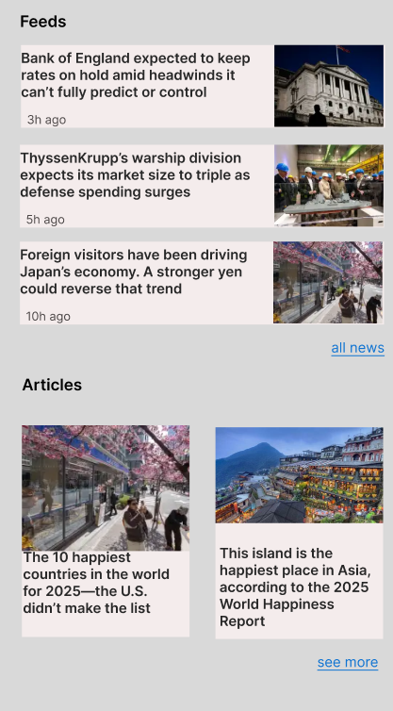
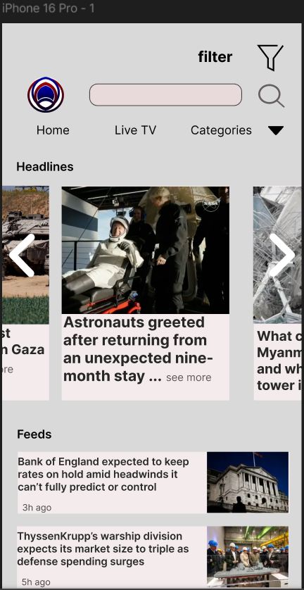

Hover: with the menu bar.
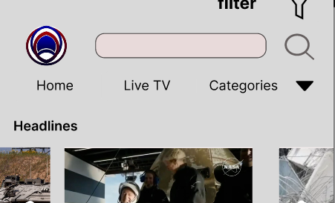

Dropdown: with categories
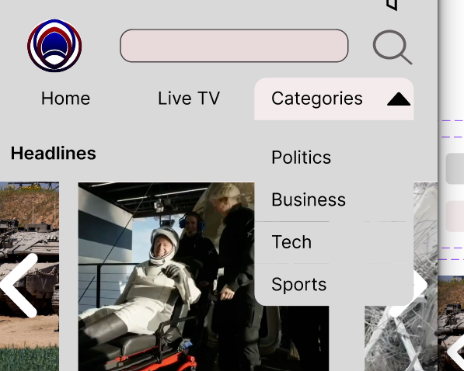

Filter:
